Name:_____________________________________
Date:_____________
Time on Task:_____________
Make/Model/Year:____________________________________
VIN:_________________________________
Evaluation (Enter number from 4, 3, 2, 1) :_________
Meets ASE Task: : (A3-E.3-2) P-1 Remove and replace drive axle shafts. (A3-E.3-3) P-2 Inspect and replace drive axle shaft seals, bearings, and retainers.

Drive Axle Shaft Service
Page 396

1. Check service information for the specified procedure to follow when inspecting and

replacing drive axle shafts. Describe specified procedure. ________________________

____________________________________________________________________

____________________________________________________________________
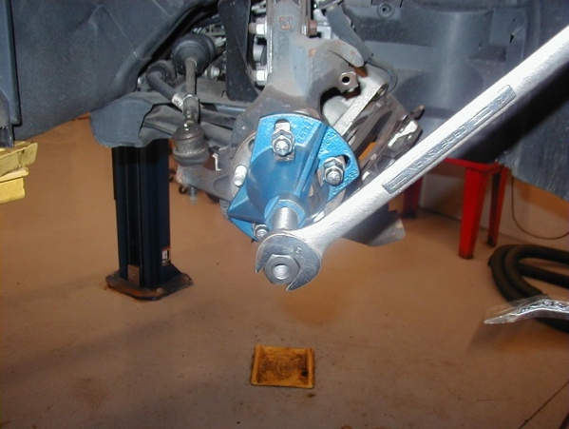

2. List the tools required. Check all that apply:
Lug nut wrench
Torque wrench
Spindle nut socket
CV boot protector
Axle puller
Other (describe) ____________________________________________
________________________________________________________
3. Inspect bearings, seals, and retainers. ___________________________________
4. Measure drive axle flange runout. What is the needed action? _______________
______________________________________________________________
______________________________________________________________

