Name:_____________________________________
Date:_____________
Time on Task:_____________
Make/Model/Year:____________________________________
VIN:_________________________________
Evaluation (Enter number from 4, 3, 2, 1) :_________
Meets ASE Task: : (A3-D-2) P-1 Inspect, service, and/or replace shafts, yokes, boots, and universal/CV joints.

U-Joint and CV Joint Service
Page 395
1. Check service information and determine the specified procedures, tools, and torque
specification needed to service CV joints.

Specified procedure: ________________________________________________
___________________________________________________________
Tools/equipment: ___________________________________________________
___________________________________________________________
Torque specification: ________________________________________________

2. Following the specified procedure, remove the drive axle shaft assembly.
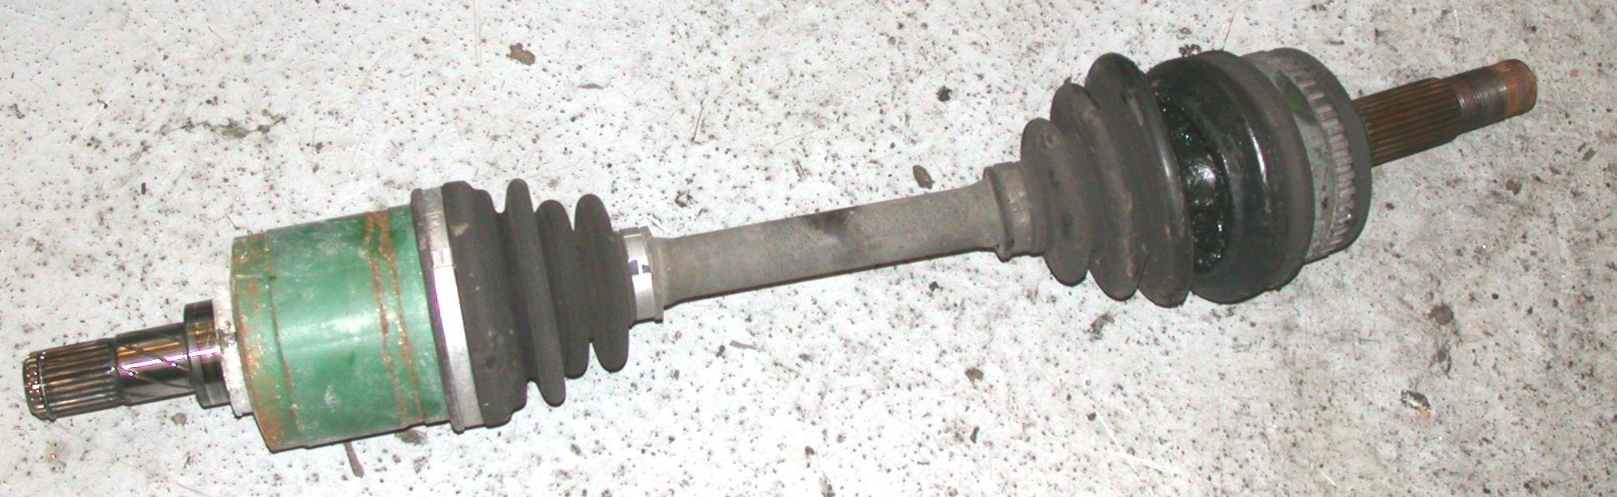
Instructor’s check ____________

3. Following the specified installation procedure, check all that were replaced.

Drive axle shaft assembly CV joint and boot
CV joint boot only Other (specify) ___________________

4. Reinstall the drive axle shaft assembly.

Instructor’s OK ______________

