Name:_____________________________________
Date:_____________
Time on Task:_____________
Make/Model/Year:____________________________________
VIN:_________________________________
Evaluation (Enter number from 4, 3, 2, 1) :_________
Meets ASE Task: : (A3-D-4) P-1 Diagnose constant-velocity (CV) joint noise and vibration concerns; determine needed action.

CV Joint Noise and Vibration Diagnosis
Page 394
1. Check service information for the specified procedure that should be followed when
diagnosing CV joint noise and/or vibration concerns.
__________________________________________________________________
__________________________________________________________________

2. Check all that were specified:

Drive backward while turning Drive in a circle to the left and right
Drive forward while turning Drive at highway speed
Drive forward straight ahead Drive in reverse straight ahead
Other (specify) _______________________________________________

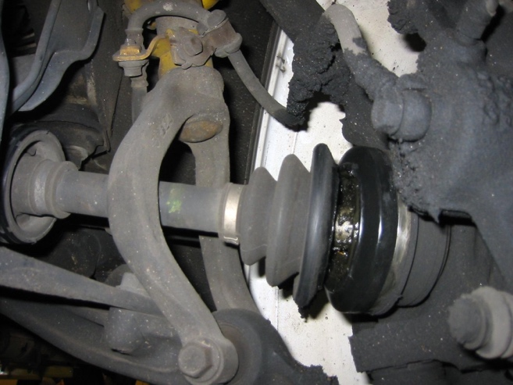

3. Most vehicle manufacturers specify that the engine and transmission/transaxle mounts
be checked for damage or wear. What are the conditions of the mounts?

__________________________________________________________________

4. Based on the inspection and testing, what is the needed action? __________________
__________________________________________________________________

