Name:_____________________________________
Date:_____________
Time on Task:_____________
Make/Model/Year:____________________________________
VIN:_________________________________
Evaluation (Enter number from 4, 3, 2, 1) :_________
Meets ASE Task: : (A3-C-6) P-3 Disassemble, inspect, clean, and reassemble internal transmission/transaxle components.

Disassemble and Reassemble Transmission/Transaxle
Page 393
1. Check service information for the exact procedures to follow when disassembling the
manual transmission/transaxle (describe procedures). ____________________________
____________________________________________________________________
____________________________________________________________________
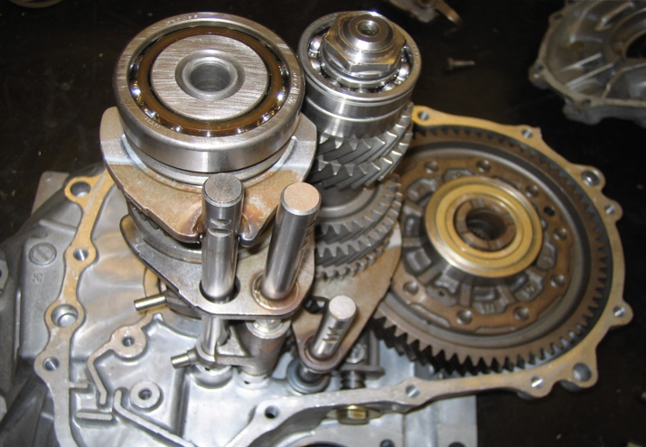

2. List all tools needed.
a. _______________ d. _______________ g. _______________
b. _______________ e. _______________ h. _______________
c. _______________ f. _______________ i. _______________
3. Check service information for the specified assembly procedures, including the
measurements and clearances that should be checked (describe procedure).
____________________________________________________________________
____________________________________________________________________
4. List the measurements and clearances. ________________________________________
____________________________________________________________________
____________________________________________________________________

