Name:_____________________________________
Date:_____________
Time on Task:_____________
Make/Model/Year:____________________________________
VIN:_________________________________
Evaluation (Enter number from 4, 3, 2, 1) :_________
Meets ASE Task: : (A3-C-1) P-2 Describe the operational characteristics of an electronically controlled manual transmission/transaxle.

Electronically Controlled Manual Transmission
Page 389
1. Check service information and determine the operational characteristics of an electronically
controlled manual transmission/transaxle. ____________________________________
___________________________________________________________________
___________________________________________________________________
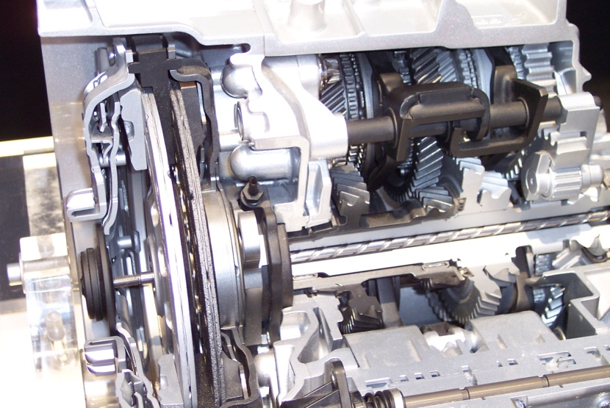

2. List the terms used to describe this type of transmission/transaxle. (Perform a Google
search.) _____________________________________________________________
_________________________________________________________________
_________________________________________________________________
_________________________________________________________________
3. What are the advantages and disadvantages of an electronically controlled manual
transmission/transaxle?
Advantages: _______________________________________________________
____________________________________________________________
Disadvantages: _____________________________________________________
____________________________________________________________

