Name:_____________________________________
Date:_____________
Time on Task:_____________
Make/Model/Year:____________________________________
VIN:_________________________________
Evaluation (Enter number from 4, 3, 2, 1) :_________
Meets ASE Task: : (A3-A-5) P-1 Drain and refill manual transmission/transaxle and final drive unit; use proper fluid type per manufacturer specification.

Drain and Fill Manual Transmission/Transaxle
Page 387
1. List the brand name and designation of the manual transmission/transaxle.
Brand name ____________________ Designation ______________________
2. List the specified lubricant and the capacity.
Lubricant ______________________ Capacity __________
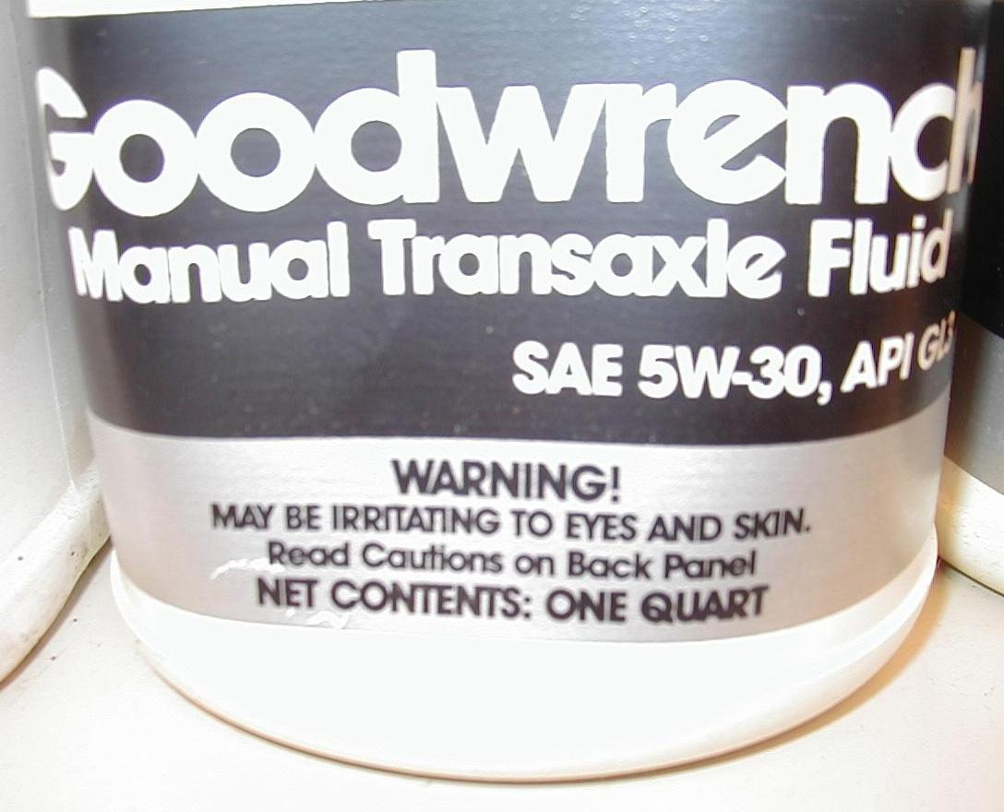
3. List the number of forward gears and the gear ratio for each.
Number of forward gears:
3-speed
4-speed
5-speed
6-speed
4. Determine the specified
Manual transmission/
transaxle fluid. Describe
the specified fluid.
_______________________
5. Check service information for the fluid capacity of the manual transmission/transaxle.

What is the specified capacity? _________

6. Describe the location of the drain and fill plugs. ________________________________

_______________________________________________________________________

7. Describe the condition of the old fluid. _______________________________________

_______________________________________________________________________

