Name:_____________________________________
Date:_____________
Time on Task:_____________
Make/Model/Year:____________________________________
VIN:_________________________________
Evaluation (Enter number from 4, 3, 2, 1) :_________
Meets ASE Task: : (A3-A-4) P-1 Check fluid condition; check for leaks; determine needed action.

Manual Transmission Fluid Level
Page 386
1. Check the service information for correct fluid and for the location of level plug.
Inspection location _______________________________________________
Recommended fluid_______________________________________________
2. Hoist the vehicle safely.

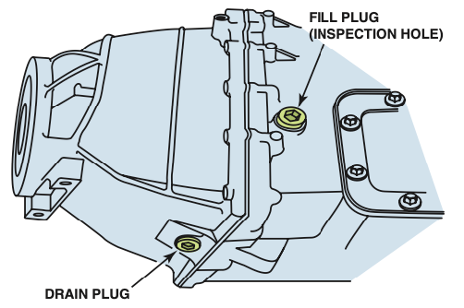
3. Inspect the fluid level and replace as required or recommended.
Level OK
Level low – added fluid
Drained and replaced fluid
4. Any visible leaks? No Yes (If yes, describe) _________________________
____________________________________________________________________
5. Based on the inspection, what is the needed action? ______________________________
____________________________________________________________________

