Name:_____________________________________
Date:_____________
Time on Task:_____________
Make/Model/Year:____________________________________
VIN:_________________________________
Evaluation (Enter number from 4, 3, 2, 1) :_________
Meets ASE Task: : (A3-B-8) P-3 Describe the operation and service of a system that uses a dual mass flywheel.

Dual-Mass Flywheel
Page 385
1. Check service information and check for the specified service procedures that may be
needed to be performed on a vehicle equipped with a dual-mass flywheel.
__________________________________________________________________
__________________________________________________________________
__________________________________________________________________
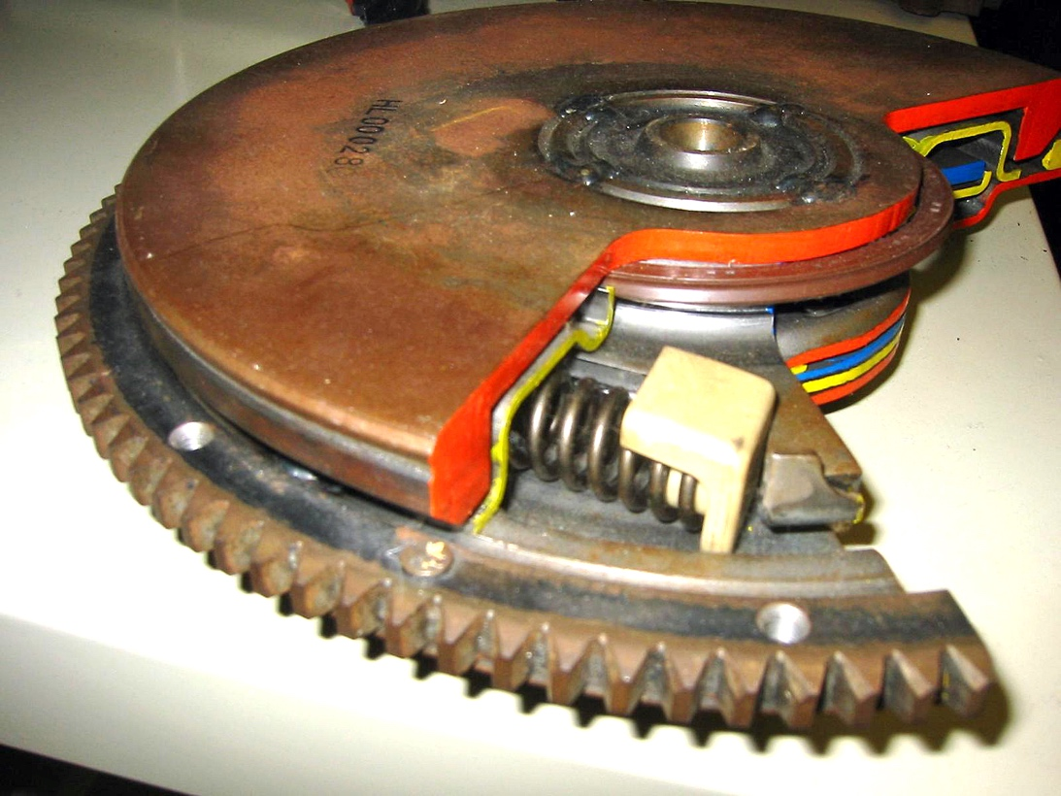

2. Describe why a dual-mass flywheel is used in some vehicles. ___________________
_________________________________________________________________
_________________________________________________________________

