Name:_____________________________________
Date:_____________
Time on Task:_____________
Make/Model/Year:____________________________________
VIN:_________________________________
Evaluation (Enter number from 4, 3, 2, 1) :_________
Meets ASE Task: : (A3-B-7) P-2 Measure flywheel runout and crankshaft end play; determine needed action.

Flywheel Runout
Page 384
1. Check service information for the specified flywheel runout testing procedures and
specifications. Describe the testing procedure. _________________________________
____________________________________________________________________
____________________________________________________________________
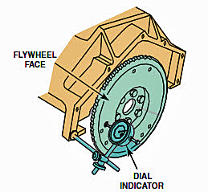

2. What is the specified flywheel runout? _____________________
3. What was the runout? OK NOT OK
4. What is the specified crankshaft endplay? _______________________
5. How much crankshaft endplay was measured? ________________________
6. Based on the test results, what is the needed action? _____________________________
____________________________________________________________
____________________________________________________________

