Name:_____________________________________

Date:_____________

Time on Task:_____________

Make/Model/Year:____________________________________

VIN:_________________________________

Evaluation (Enter number from 4, 3, 2, 1) :_________

**Meets ASE Task: :** (A3-B-6) P-2 Inspect flywheel and ring gear for wear, cracks, and discoloration; determine needed action.

**Flywheel and Ring Gear Inspection**

Page 383

**1.** Check service information and determine what should be checked when inspecting a

flywheel and ring gear (describe recommended inspection procedure). ______________

____________________________________________________________________

____________________________________________________________________

____________________________________________________________________

____________________________________________________________________

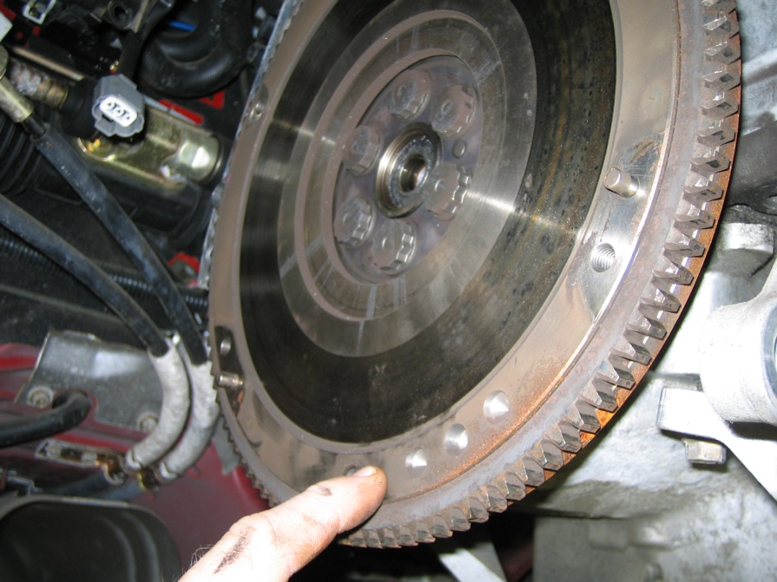

**2.** Based on the inspection and the service information recommendations, what is the

needed action? _________________________________________________________

___________________________________________________________________

___________________________________________________________________