Name:_____________________________________
Date:_____________
Time on Task:_____________
Make/Model/Year:____________________________________
VIN:_________________________________
Evaluation (Enter number from 4, 3, 2, 1) :_________
Meets ASE Task: : (A3-B-5) P-2 Bleed clutch hydraulic system.

Bleed Clutch Hydraulic System
Page 381
1. Check service information for the specified procedures to follow when bleeding air from
the clutch hydraulic system. ________________________________________________
____________________________________________________________________
____________________________________________________________________
____________________________________________________________________
____________________________________________________________________
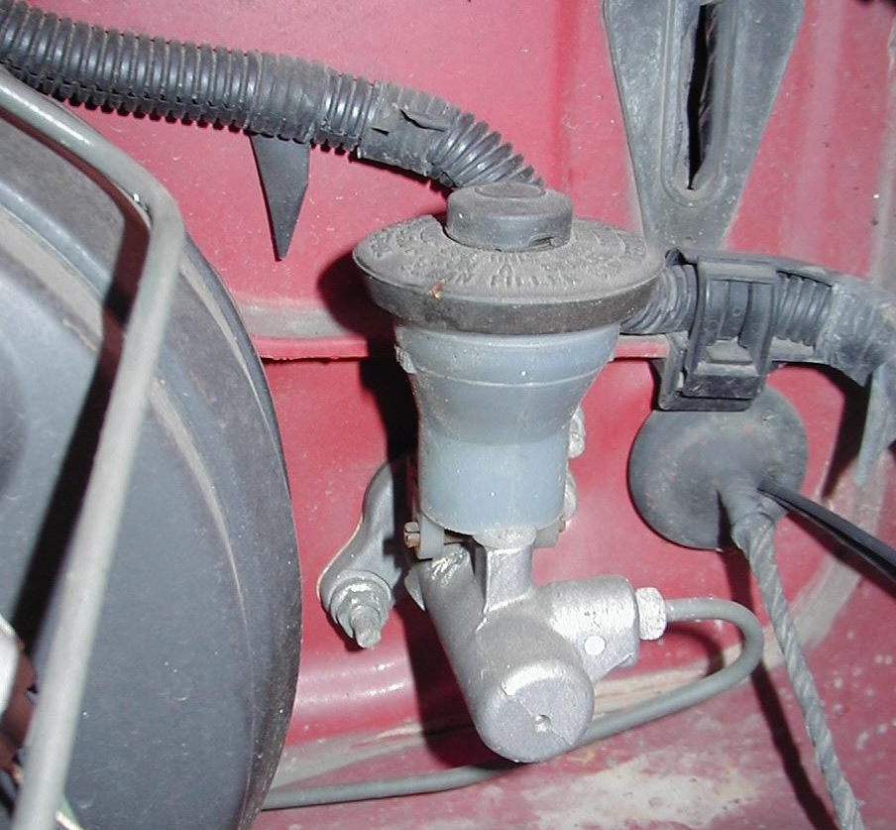

2. What is the recommended fluid? _____________________________________

