Name:_____________________________________
Date:_____________
Time on Task:_____________
Make/Model/Year:____________________________________
VIN:_________________________________
Evaluation (Enter number from 4, 3, 2, 1) :_________
Meets ASE Task: : (A3-B-4) P-2 Inspect and/or replace clutch pressure plate assembly, clutch disc, release (throw-out) bearing/ linkage, and pilot bearing/bushing (as applicable).

Inspect/Replace Clutch Components
Page 380
1. Check service information and determine the specified tests and inspections
recommended to be performed (describe). _____________________________________
____________________________________________________________________
____________________________________________________________________
____________________________________________________________________
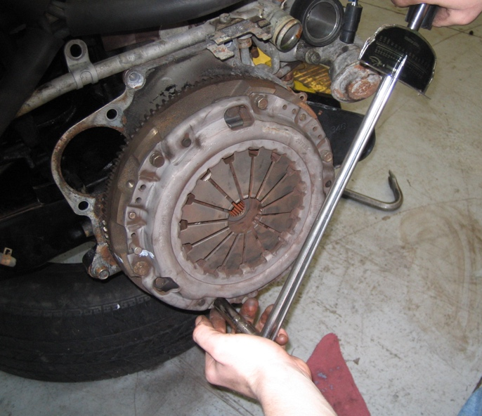

2. Based on the inspection, what is the needed action? _____________________________
____________________________________________________________________
____________________________________________________________________
____________________________________________________________________

