Evaluation (Enter number from 4, 3, 2, 1) :_________
Meets ASE Task: (A4-F-2) P-1 Rotate tires according to manufacturer’s recommendation including vehicles equipped with tire pressure monitoring systems (TPMS).

Tire Rotation

Name:_____________________________________
Date:_____________
Time on Task:_____________
Make/Model/Year:____________________________________
VIN:_________________________________
Page 38
1. Check service information and determine the manufacturer’s recommendations for tire

rotation. _____________________________________________________________

_________________________________________________________________
2. Remove the tires and move them to their new position. Which rotation pattern was
used? _______________________________________________________________
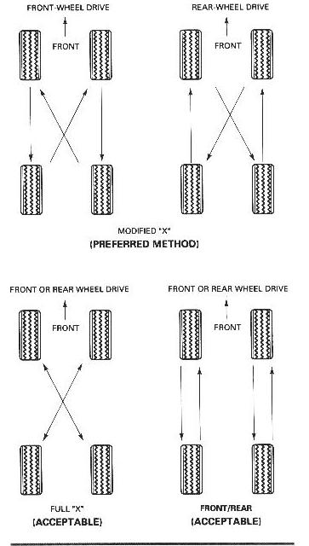
3. Install the lug nuts and torque to specifications using a
torque wrench or torque absorbing adapter on an air impact
wrench. What is the specified lug nut torque? __________
____________________________________________

4. Check and adjust tire pressures as necessary as per the
specifications for the vehicle. What is the specified
inflation pressure? ________________________________
____________________________________________

