Name:_____________________________________
Date:_____________
Time on Task:_____________
Make/Model/Year:____________________________________
VIN:_________________________________
Evaluation (Enter number from 4, 3, 2, 1) :_________
Meets ASE Task: : (A3-B-3) P-2 Inspect clutch pedal linkage, cables, automatic adjuster mechanisms, brackets, bushings, pivots, and springs; perform needed action.

Clutch Linkage Inspection
Page 379
1. Check service information and determine the specified procedures to follow when
inspecting clutch linkage, cables, and self-adjusters (describe procedures). ___________
____________________________________________________________________
____________________________________________________________________
____________________________________________________________________
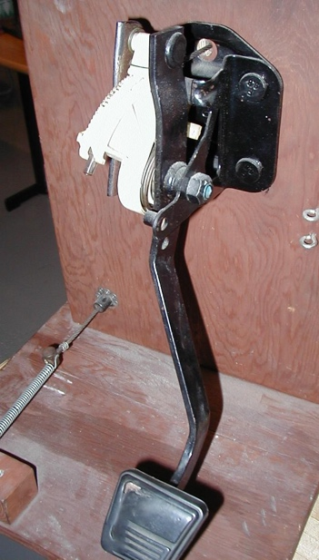
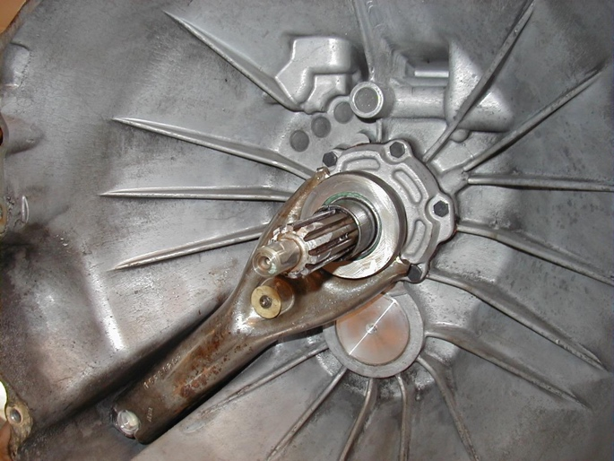

2. What type of linkage is used on the vehicle being inspected?
Hydraulic
Cable
Rods and pivots
Other (describe) _________________________________________________
3. Is the linkage self-adjusting? Yes No
4. Based on the inspection, what is the needed action? _____________________________
____________________________________________________________________
____________________________________________________________________
____________________________________________________________________

