Name:_____________________________________
Date:_____________
Time on Task:_____________
Make/Model/Year:____________________________________
VIN:_________________________________
Evaluation (Enter number from 4, 3, 2, 1) :_________
Meets ASE Task: : (A3-B-2) P-2 Diagnose clutch noise, binding, slippage, pulsation, and chatter; determine needed action.

Diagnose Clutch Concerns
Page 378
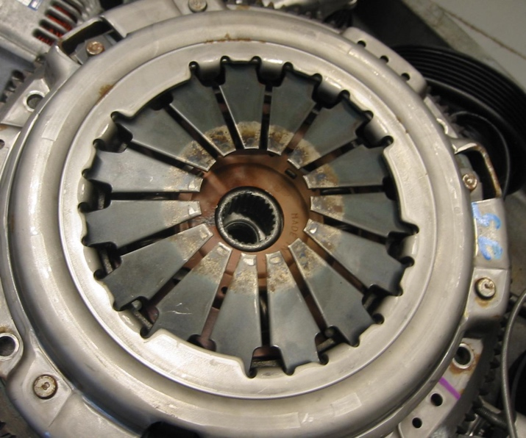
1. Check service information and describe
what diagnostic procedures should be
followed to determine the cause of clutch
noise, binding, slippage, pulsation, and
chatter. __________________________
_________________________________
_________________________________
_________________________________
_________________________________
_________________________________
2. What is the primary customer concern?
Noise (describe) _______________________________________________
Binding
Slippage (When? Under what conditions?) __________________________
____________________________________________________________
Pulsation
Chatter
Other (describe) ________________________________________________
3. Based on the results of the specified diagnostic procedures, what is the needed action?
___________________________________________________________________
___________________________________________________________________
___________________________________________________________________

