**Meets ASE Task: :** (A4-E-6) P-1 Check rear wheel thrust angle; determine needed action. (A4-E-7) P-2 Check for front wheel setback; determine needed action. (A4-E-8) P-2 Identify front and/or rear cradle (subframe) misalignment; determine needed action.

Name:_____________________________________

Date:_____________

Time on Task:_____________

Make/Model/Year:____________________________________

VIN:_________________________________

Evaluation (Enter number from 4, 3, 2, 1) :_________

**Diagnostic Alignment Angles**

Page 377

1. Measure the rear thrust angle and compare it to factory specifications.

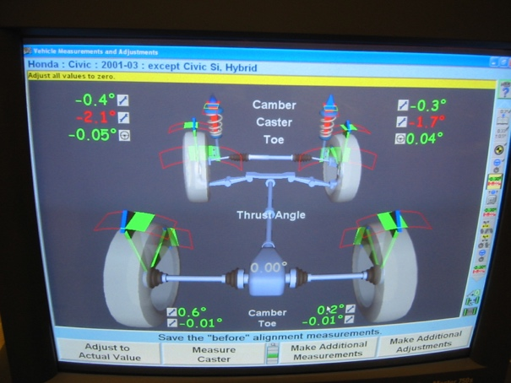

Measured rear thrust angle = ______________

Specified thrust angle = ___________________

2. Based on the results of the rear thrust angle

measurement, what is the needed action.?

_________________________________________

_________________________________________

3. Measure the front wheel setback and compare it to factory specifications.

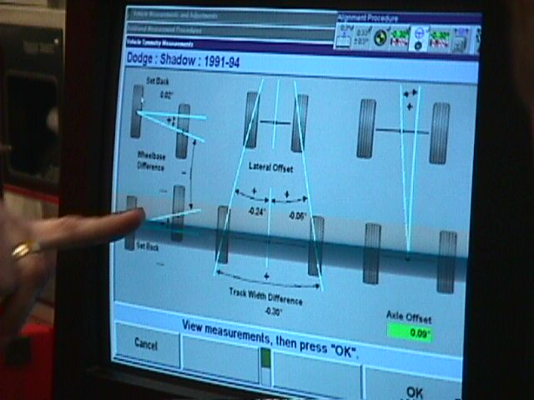 Measured front wheel setback = __________________

Specified front wheel setback = ___________________

4. Based on the results of the front wheel setback

measurement, what is the needed action.?

_________________________________________

_________________________________________

5. Check service information for the specified location and dimensions to check for the

proper alignment of the front and/or rear cradle (subframe).

__________________________________________________________________

__________________________________________________________________

6. Based on the results of the measurements, compared to factory specifications, what is

the needed action?

__________________________________________________________________