Meets ASE Task: : (A4-E-4) P-2 Check toe-out-on-turns (turning radius); determine needed action. (A4-E-5) P-2 Check steering axis inclination (SAI) and included angle; determine needed action.

Name:_____________________________________
Date:_____________
Time on Task:_____________
Make/Model/Year:____________________________________
VIN:_________________________________
Evaluation (Enter number from 4, 3, 2, 1) :_________
TOOT and SAI
Page 375
1. Check the alignment equipment instructions and measure the toe-out-on-turns.
LEFT TOOT RIGHT TOOT

___________ _____________
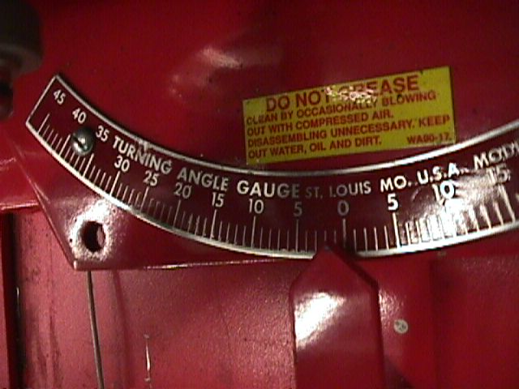
2. Check service information for the specified toe-out-on-turns
(TOOT).
Specifications = ____________________________

3. Based on the TOOT readings, what is the needed action?

__________________________________________________________________

__________________________________________________________________

4. Check steering axis inclination (SAI) and compare to factory specifications.

SAI LEFT SAI RIGHT

_________ __________

Specification for SAI = ________________________________

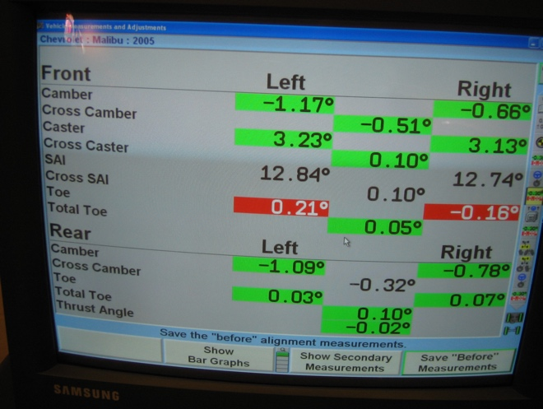
5. Based on the SAI reading, what is the
needed action?

__________________________________

__________________________________

__________________________________

