Meets ASE Task: : (A4-E-3) P-1 Prepare vehicle for wheel alignment on alignment machine; perform four-wheel alignment by checking and adjusting front and rear wheel caster, camber; and toe as required; center steering wheel.

Name:_____________________________________
Date:_____________
Time on Task:_____________
Make/Model/Year:____________________________________
VIN:_________________________________
Evaluation (Enter number from 4, 3, 2, 1) :_________
Alignment Angle Readings
Page 374
1. Hoist the vehicle on the alignment rack and install the wheel sensors.

2. Compensate the wheel sensors as per the alignment equipment manufacturer’s
recommended procedure.

3. Lower the vehicle and jounce (bounce) to center the suspension.

4. Read the rear camber and toe.

LR RR
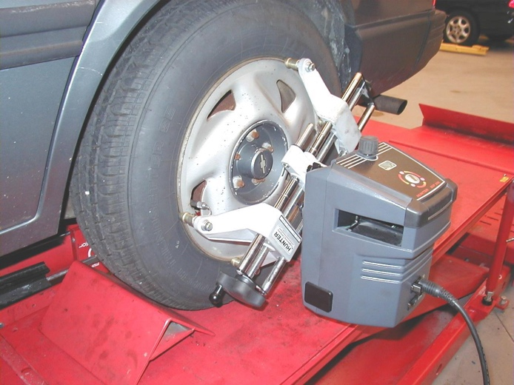
Camber _____ _____
Toe _____ _____

Total rear toe = _______

5. Read the front camber and toe.

LF RF
Camber _____ _____
Toe _____ _____

Total front toe = _______

6. Perform a caster sweep to determine the front caster and SAI.

LF RF
Caster _____ _____
SAI _____ _____

Describe what (if anything) is wrong with the present alignment.

___________________________________________________

