Meets ASE Task: : (A4-E-1) P-1 Perform pre-alignment inspection, measure vehicle ride height; determine needed action.

Name:_____________________________________
Date:_____________
Time on Task:_____________
Make/Model/Year:____________________________________
VIN:_________________________________
Evaluation (Enter number from 4, 3, 2, 1) :_________
Pre-Alignment Inspection
Page 372
1. Check tires. Both front tires and both
rear tires should be checked for the
following:

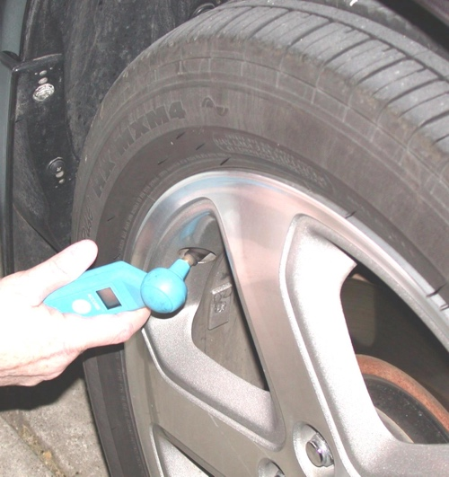
A. Correct tire pressure

B. Same size and brand

C. Same tread depth

OK NOT OK

2. Perform a dry-park test to check for any looseness in the steering and suspension
components such as:
A. Tie rods

B. Idler arms

C. Ball-joints

D. Control arm bushings

E. Loose or defective wheel bearings

OK NOT OK

3. Check for proper ride height.
A. Front and rear

B. Left and right

OK NOT OK

