Evaluation (Enter number from 4, 3, 2, 1) :_________
Meets ASE Task: (A1-D-5) P-1 Inspect, replace, and/or adjust drive belts, tensioners, and pulleys; check pulley and belt alignment.

Accessory Drive Belt Inspection

Name:_____________________________________
Date:_____________
Time on Task:_____________
Make/Model/Year:____________________________________
VIN:_________________________________
Page 37
Proper operation of the alternator and the charging system as well as the water (coolant) pump and other cooling systems depend on the accessory drive belt(s).

Serpentine (poly-V) belt:

1. Check for cracks - replace if more than 3 cracks in any one rib in 3 inches.

2. Check for proper tension - check the tensioner notch location for proper tension
position.
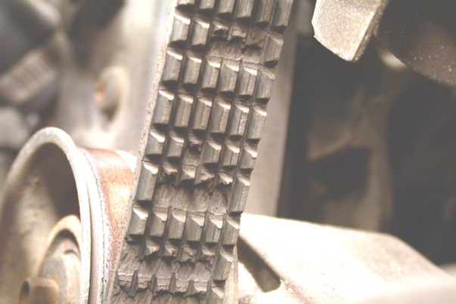
OK NOT OK

V-belts:

1. Check belt tension:
- usual specifications is 70 to 100 lb. of tension using a belt tension gauge.
- maximum of ½” deflection.

OK NOT OK

2. Check the belt for flaying, cracks, and glazing.

OK NOT OK

3. Check pulley adjustment.

OK NOT OK

