Meets ASE Task: : (A4-B-18) P-3 Test power steering system pressure; determine needed action.

Name:_____________________________________
Date:_____________
Time on Task:_____________
Make/Model/Year:____________________________________
VIN:_________________________________
Evaluation (Enter number from 4, 3, 2, 1) :_________
Power Steering System Pressure Test
Page 368
_____ 1. Check service information and determine what tools and equipment are needed to
check power steering system pressure. List the tools/equipment needs. __________
_________________________________________________________________
_________________________________________________________________
_________________________________________________________________
_____ 2. What is the specified procedure? Describe: _________________________________
_________________________________________________________________
_________________________________________________________________
_____ 3. What is the pressure specification? ________________________________________
_____ 4. What were the test results? ______________________________________________
_________________________________________________________________
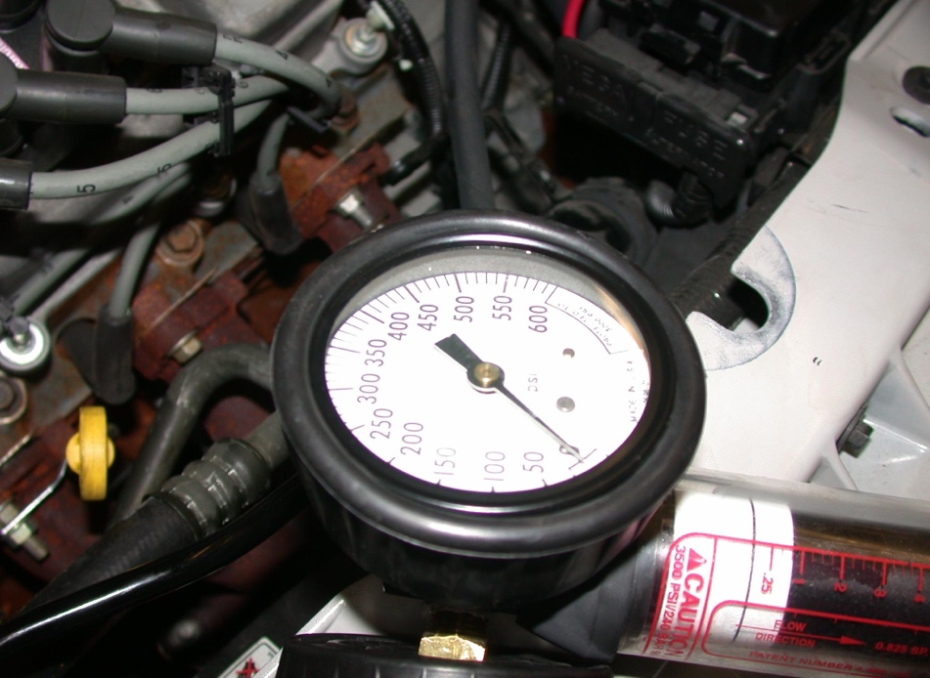
_____ 5. Based on the test results, what is the needed action? __________________________
________________________________________________________________
________________________________________________________________

