Meets ASE Task: : (A4-B-6) P-2 Inspect, remove and/or replace power steering hoses and fittings.

Name:_____________________________________
Date:_____________
Time on Task:_____________
Make/Model/Year:____________________________________
VIN:_________________________________
Evaluation (Enter number from 4, 3, 2, 1) :_________
Inspect Power Steering Hoses and Fittings
Page 367
1. Check the service information for the specified procedures, precautions, and torque
specifications.
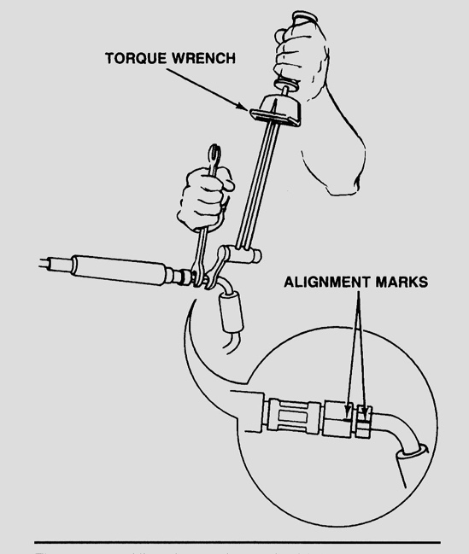
A. Specified procedure: _________________
__________________________________
B. Specified precautions: ________________
__________________________________
C. Specified torque specifications _________
__________________________________

2. Check the reason why the hoses and/or fittings are
being replaced.

Leaking
Worn outside cover
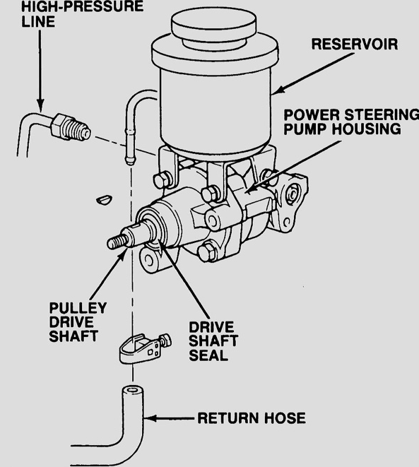
Possible restriction as determined by testing
Recommended when replacing pump or
gear assembly
Other (specify) ____________________
________________________________

3. Which hose(s) or fitting(s) was replaced?

High-pressure hose and fitting
Low-pressure hose and fitting
Other (specify) ____________________
_________________________________

