**Meets ASE Task: :** (A4-B-16) P-2 Remove and reinstall power steering pump. (A4-B-17) P-2 Remove and reinstall press fit power steering pump pulley; check pulley and belt alignment.

Name:_____________________________________

Date:_____________

Time on Task:_____________

Make/Model/Year:____________________________________

VIN:_________________________________

Evaluation (Enter number from 4, 3, 2, 1) :_________

**Service Power Steering Pump**

Page 366

1. Check service information for the specified procedures and specifications for

removing, replacing, and adjusting the power steering pump and drive belt. Describe

the recommended procedure.

__________________________________________________________________

__________________________________________________________________

Specified belt tension = ____________________

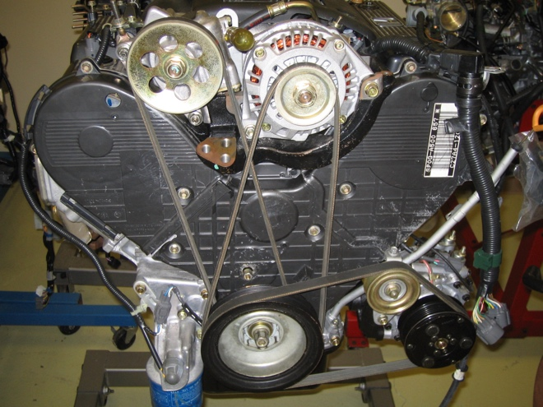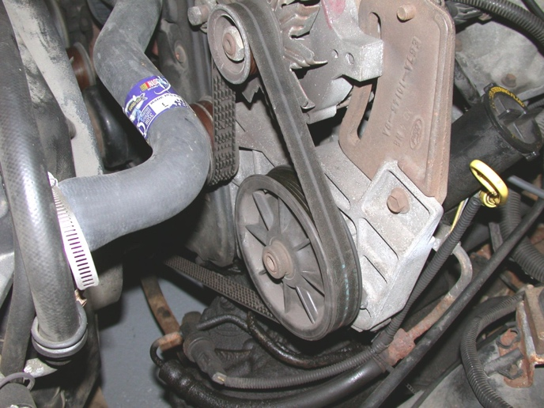

2. Remove and reinstall power steering pump assembly. **Instructor check** __________

3. Check service information for the specified procedure to follow to remove and

reinstall the power steering pump drive pulley. Describe the recommended procedure.

__________________________________________________________________

__________________________________________________________________

List the tools required. _______________________________________________

**Instructor check** ________