Meets ASE Task: : (A4-B-5) P-2 Remove, inspect, replace, and/or adjust power steering pump drive belt.

Name:_____________________________________
Date:_____________
Time on Task:_____________
Make/Model/Year:____________________________________
VIN:_________________________________
Evaluation (Enter number from 4, 3, 2, 1) :_________
Power Steering Pump Belt
Page 365
1. Check service information for the specified procedure and specifications when
inspecting, replacing, and/or adjusting the power steering pump drive belt. Describe
the specified procedure. _________________________________________________
__________________________________________________________________
2. How many grooves on the pulley belt: ______________________
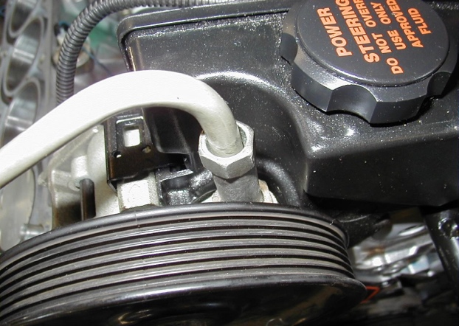

3. Does the power steering pump drive belt use a tensioner? Yes No
If yes, does service information specify a tension test procedure?
__________________________________________________________________
