Meets ASE Task: : (A4-B-2) P-2 Inspect power steering fluid level and condition. (A4-B-3) P-2 Drain and replace power steering system fluid; use proper fluid type per manufacturer specification.
Name:_____________________________________
Date:_____________
Time on Task:_____________
Make/Model/Year:____________________________________
VIN:_________________________________
Evaluation (Enter number from 4, 3, 2, 1) :_________
Power Steering Fluid
Page 363
1. Check service information for the specified fluid to use in the power steering system.
Specified fluid = ________________________________________
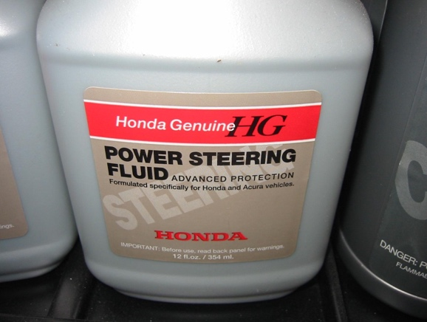

2. Check service information for the specified procedure to follow when flushing, filling,
and bleeding a power steering system. List the recommended steps:
Step 1 ______________________________________________________
Step 2 ______________________________________________________
Step 3 ______________________________________________________
Step 4 ______________________________________________________
