Meets ASE Task: : (A4-B-12) P-3 Diagnose power steering gear (non-rack and pinion) binding, uneven turning effort, looseness, hard steering, and noise concerns; determine needed action.
(A4-B-13) P-1 Diagnose power steering gear (rack and pinion) binding, uneven turning effort, looseness, hard steering, and noise concerns; determine needed action.

Name:_____________________________________
Date:_____________
Time on Task:_____________
Make/Model/Year:____________________________________
VIN:_________________________________
Evaluation (Enter number from 4, 3, 2, 1) :_________
Steering Gear Diagnosis
Page 362
1. Check service information for the specified procedure to follow when diagnosing
conventional steering gear mechanical and noise concerns. Describe the
recommended procedures.

_________________________________________________________________

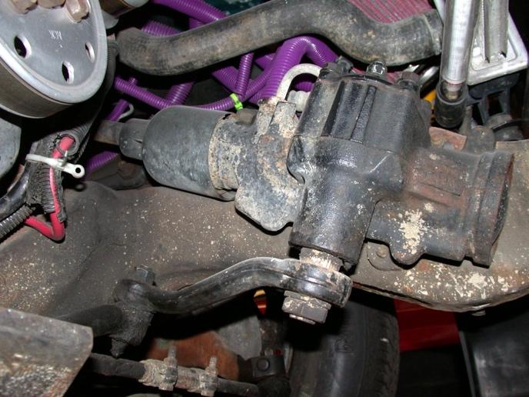
_________________________________________________________________

2. Check service information for the specified procedures to follow when diagnosing a
rack and pinion steering gear assembly. Describe the recommended procedures.
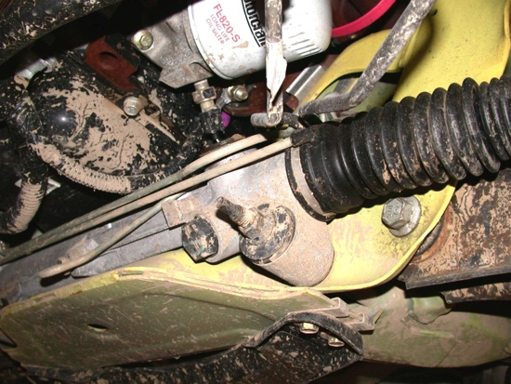
______________________________________

______________________________________

______________________________________

3. Based on the diagnosis, what is the needed action?

_______________________________________

