Name:_____________________________________
Date:_____________
Time on Task:_____________
Make/Model/Year:____________________________________
VIN:_________________________________
Evaluation (Enter number from 4, 3, 2, 1) :_________
Meets ASE Task: : (A4-B-7) P-2 Inspect, remove and/or replace pitman arm, relay (centerlink/intermediate) rod, idler arm and mountings, and steering linkage damper.
Inspect and Replace Steering Components
Page 360
_____ 1. Check the service information for the specified testing and inspection procedures and
specifications.
A. Specified testing procedures: ______________________________________
______________________________________________________________
B. Specifications: __________________________________________________
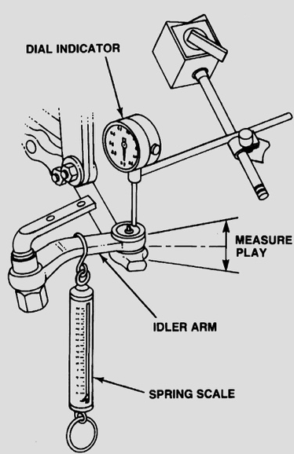
______________________________________________________________
_____ 2. Check the steering components listed and note their
condition.
Idler arm: ______________________________
Pitman arm: ____________________________
Centerlink: ____________________________
Steering linkage damper: _________________
_____ 3. State the specified replacement procedure and list any specific tools needed.
Idler arm: Procedure _______________________________________________
Tools ___________________________________________________
Pitman arm: Procedure ______________________________________________
Tools ___________________________________________________
Centerlink: Procedure _______________________________________________
Tools ___________________________________________________
Steering linkage damper: Procedure ____________________________________
Tools __________________________________________________

