Evaluation (Enter number from 4, 3, 2, 1) :_________
Meets ASE Task: (A1-D-3) P-1 Perform cooling system pressure and dye tests to identify leaks; check coolant condition and level; inspect and test radiator, pressure cap, coolant recovery tank, heater core, gallery plugs; determine needed action.

Cooling System Inspection

Name:_____________________________________
Date:_____________
Time on Task:_____________
Make/Model/Year:____________________________________
VIN:_________________________________
Page 36
1. Inspect the radiator for exterior leaks or clogged areas due to bugs, etc. Clean as
required.

OK NOT OK

2. Pressure test the cooling system. The entire system should hold about 15 psi for 5
minutes unless there is a leak.

OK NOT OK Location of Leak_______________

3. Pressure test the radiator cap. Pressure cap specification = _____
The cap holds _____ psi.

OK NOT OK

4. Check the freezing point of the coolant using a hydrometer = __________
[should be -34° F (-37° C) or lower].
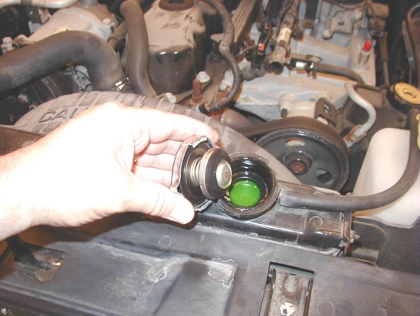
OK NOT OK

5. Check the boiling point of the coolant using a hydrometer = __________.

OK NOT OK

6. What was the needed action? ____________________

___________________________________________________________________

___________________________________________________________________

