Name:_____________________________________
Date:_____________
Time on Task:_____________
Make/Model/Year:____________________________________
VIN:_________________________________
Evaluation (Enter number from 4, 3, 2, 1) :_________
Meets ASE Task: : (A4-B-15) P-2 Remove and replace rack and pinion steering gear; inspect mounting bushings and brackets.
Steering Gear Adjustment and Replacement
Page 357
1. Check service information for the specified procedure to follow to adjust a
conventional steering gear assembly Describe the recommended procedure for:
Worm bearing preload - ___________________________________________
_________________________________________________________
Sector lash (overcenter adjustment) - _________________________________
_________________________________________________________
2. Check service information for the specified procedure to follow for replacing a rack
and pinion steering gear assembly. Describe the recommended procedures.
________________________________________________________________
________________________________________________________________
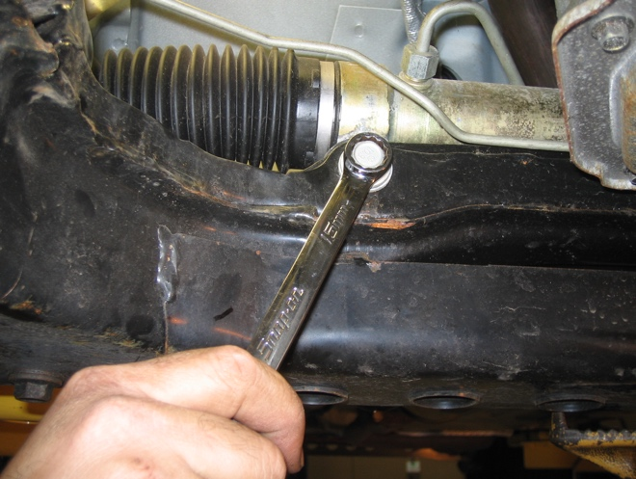

3. Describe the condition of the mounting bushings and brackets. __________________
__________________________________________________________________

