Name:_____________________________________
Date:_____________
Time on Task:_____________
Make/Model/Year:____________________________________
VIN:_________________________________
Evaluation (Enter number from 4, 3, 2, 1) :_________
Meets ASE Task: : (A4-C-9) P-1 Inspect, remove, and/or replace components of suspension systems (Coil, Leaf, and Torsion).
Inspect, Remove, or Replace Suspension Components
Page 353
1. Check service information for the specified procedure to follow when inspecting and
replacing track bar and/or strut rods. Describe the specified procedure.
_________________________________________________________________
_________________________________________________________________
_________________________________________________________________

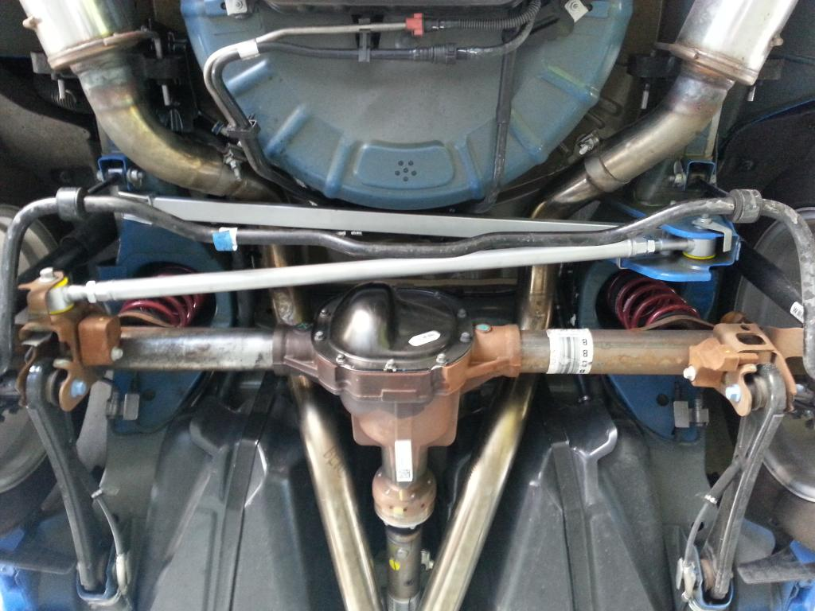

2. Describe the location of the track bar (if equipped). _________________________
________________________________________________________________
________________________________________________________________
3. Describe the location of the strut rods/radius arms (if equipped). ________________
________________________________________________________________
________________________________________________________________

