Name:_____________________________________
Date:_____________
Time on Task:_____________
Make/Model/Year:____________________________________
VIN:_________________________________
Evaluation (Enter number from 4, 3, 2, 1) :_________
Meets ASE Task: : (A4-C-9) P-1 Inspect, remove, and/or replace components of suspension systems (Coil, Leaf, and Torsion).
Rear Leaf Springs
Page 352
1. Check the service information for the specified procedure for the removal and
reinstallation of rear leaf springs.
_______________________________________________________________
_______________________________________________________________
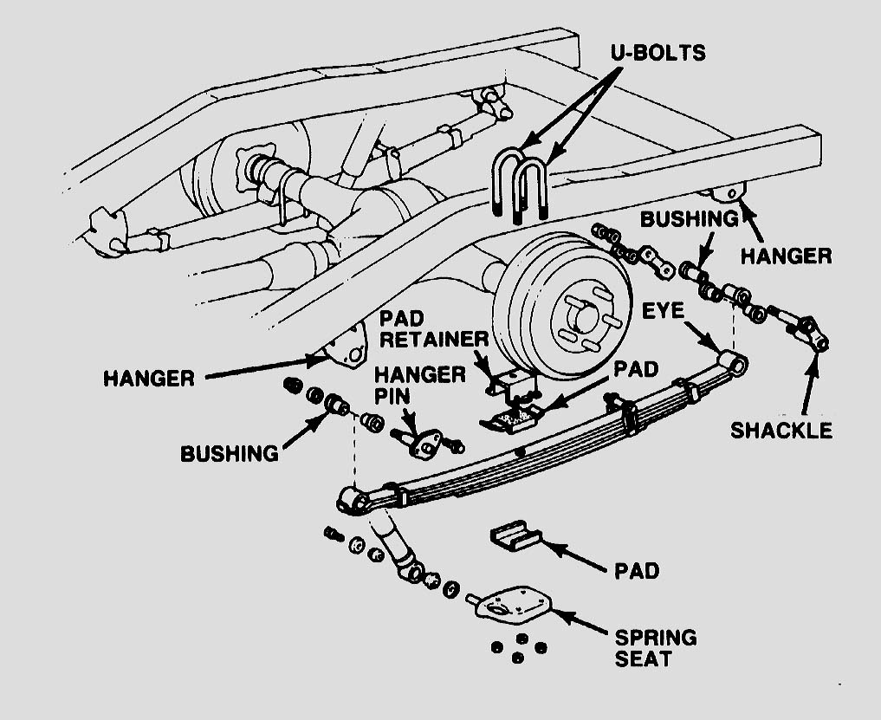
_______________________________________________________________

2. List the tools and equipment needed. _____________________________________
________________________________________________________________

3. Show the instructor the removed rear leaf spring(s). Instructor’s OK ____________

4. List the tightening torque specifications for the affected fasteners. ________________
__________________________________________________________________

