Name:_____________________________________
Date:_____________
Time on Task:_____________
Make/Model/Year:____________________________________
VIN:_________________________________
Evaluation (Enter number from 4, 3, 2, 1) :_________
Meets ASE Task: : (A4-C-8) P-2 Inspect, remove, and/or replace strut assembly, strut coil spring, insulators, and upper strut bearing mount. (A4-C-9) P-1 Inspect, remove, and/or replace components of suspension systems (Coil, Leaf, and Torsion).
MacPherson Strut Service
Page 349
1. Check the service information for the specified service procedure.

_______________________________________________________________
_______________________________________________________________
_______________________________________________________________
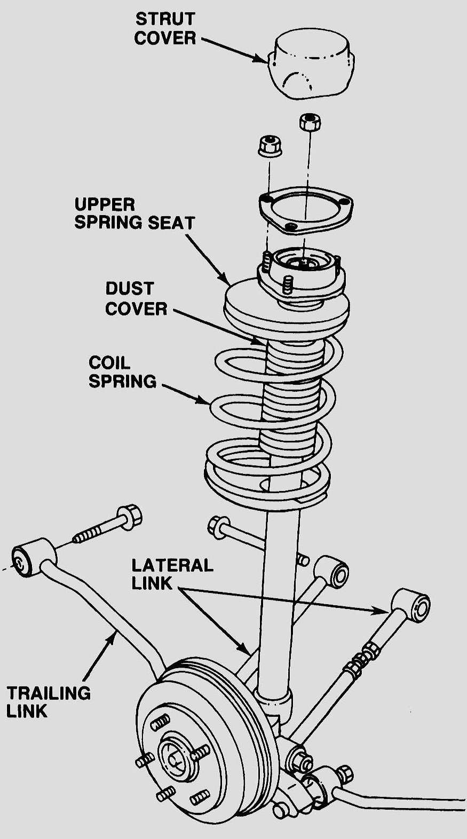
2. Safely support the vehicle on jacks and/or the
lift.

3. Remove the upper and lower attaching bolts
and nuts.

4. Carefully remove the MacPherson
strut assembly from the vehicle.

5. Compress the coil spring with the proper
equipment and replace the strut assembly.

Show the instructor the disassembled unit.

Instructor's OK _________

6. Reinstall the complete assembly.

NOTE: The vehicle should be aligned after replacing the strut assembly.

