Name:_____________________________________
Date:_____________
Time on Task:_____________
Make/Model/Year:____________________________________
VIN:_________________________________
Evaluation (Enter number from 4, 3, 2, 1) :_________
Meets ASE Task: : (A4-C-7) P-2 Inspect, remove and/or replace front/rear stabilizer bar (sway bar) bushings, brackets, and links. (A4-C-9) P-1 Inspect, remove, and/or replace components of suspension systems (Coil, Leaf, and Torsion).
Strut Rod and Stabilizer Bushings
Page 348
1. Check service information for the exact procedure to follow to remove, inspect, and
install struts and bushings. Describe the recommended steps.

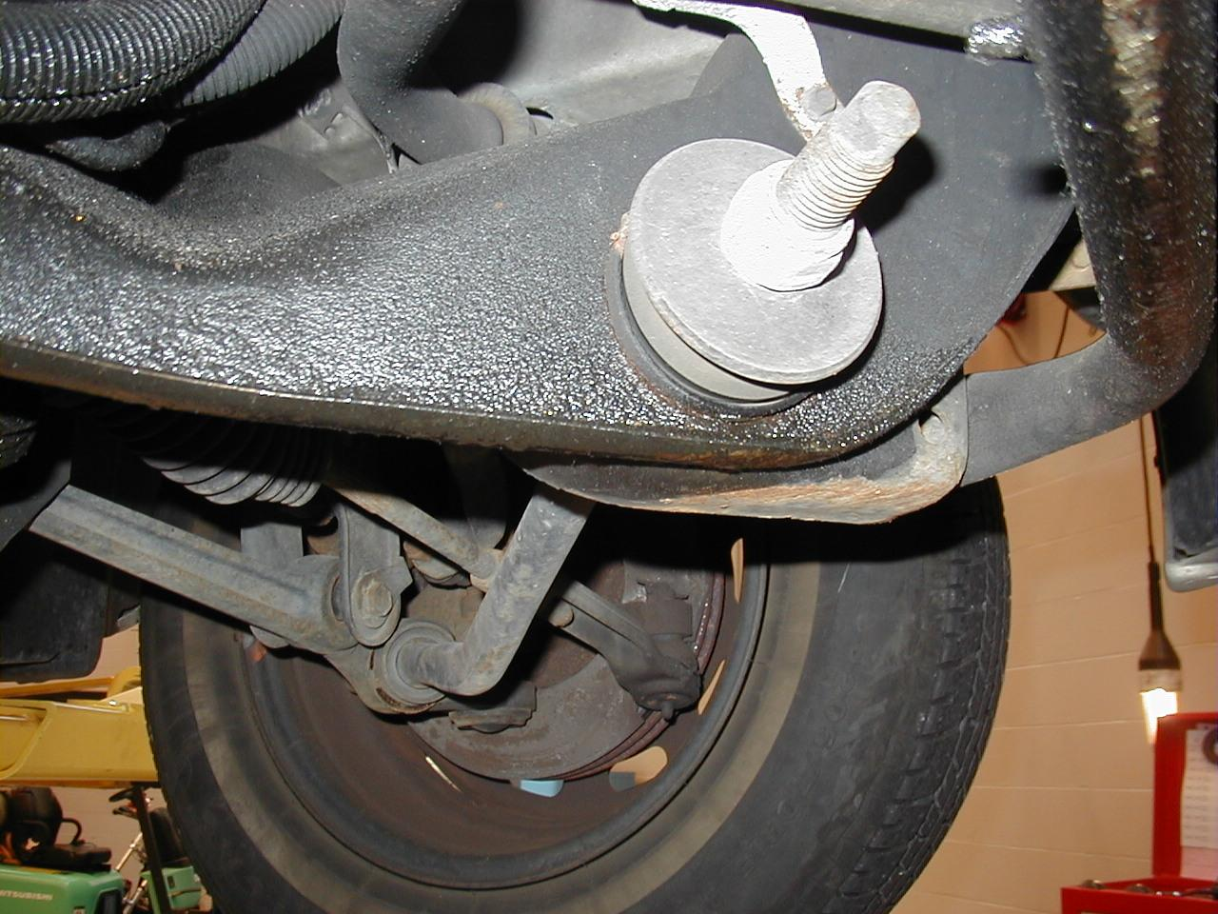
_____________________________

_____________________________

_____________________________

_____________________________

_____________________________

_____________________________

_____________________________

2. Check service information for the exact procedures to follow to remove, inspect, and
install stabilizer bar bushings. Describe the recommended steps.






