Name:_____________________________________
Date:_____________
Time on Task:_____________
Make/Model/Year:____________________________________
VIN:_________________________________
Evaluation (Enter number from 4, 3, 2, 1) :_________
Meets ASE Task: : (A4-C-6) P-3 Inspect, remove and/or replace torsion bars and mounts. (A4-C-9) P-1 Inspect, remove, and/or replace components of suspension systems (Coil, Leaf, and Torsion).
Torsion Bar
Page 347
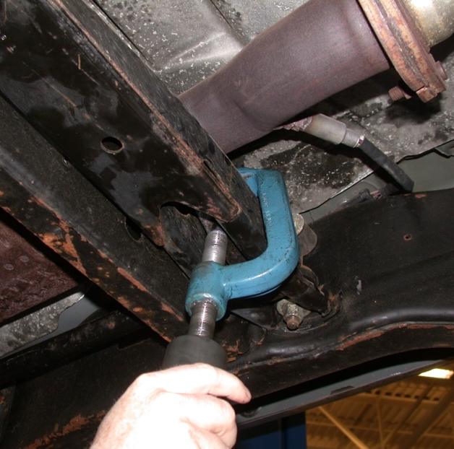
1. Check the service information for the specified
removal and reinstallation procedure.
__________________________________
__________________________________
__________________________________
__________________________________
2. List the tools needed.
_____________________________
_____________________________
_____________________________
_____________________________
_____________________________
3. Check the service information and describe
the proper ride height adjustment procedure.
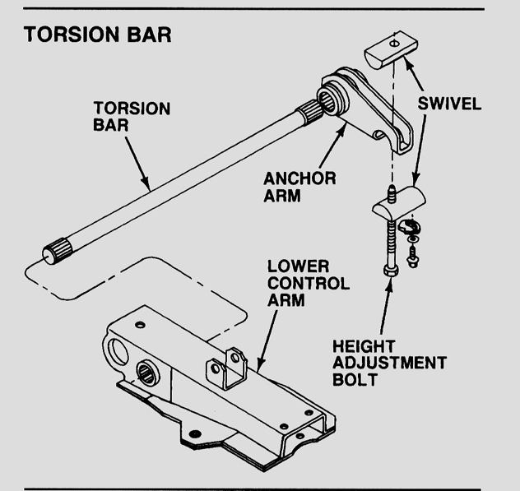
_____________________________
_____________________________
_____________________________
_____________________________
_____________________________
4. Inspect the torsion bar mounts.

OK NOT OK

Describe the faults and needed action. _______________________________
_______________________________

