Name:_____________________________________
Date:_____________
Time on Task:_____________
Make/Model/Year:____________________________________
VIN:_________________________________
Evaluation (Enter number from 4, 3, 2, 1) :_________
Meets ASE Task: : (A4-C-1) P-2, (A4-C-2) P-2, (A4-C-3) P-2, (A4-C-4) P-2, (A4-C-5) P-3
Front suspension inspection and component replacement. (A4-C-9) P-1 Inspect, remove, and/or replace components of suspension systems (Coil, Leaf, and Torsion).

Suspension Inspection/Component Replacement
Page 346
1. Check service information for the exact procedures to follow when removing,
inspecting, and replacing front suspension components. Describe the recommended
procedures.

__________________________________________________________________

__________________________________________________________________

2. Check all components that were inspected, removed, or replaced.
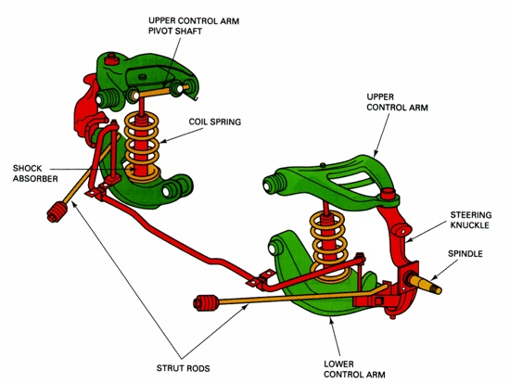
Upper control arms/bushings

Lower control arms/bushings

Strut rods/bushings

Steering knuckle

Coil springs and spring insulators

Rebound/jounce bumpers

3. Describe the reason why the parts were replaced. _____________________________

__________________________________________________________________

