Name:_____________________________________
Date:_____________
Time on Task:_____________
Make/Model/Year:____________________________________
VIN:_________________________________
Evaluation (Enter number from 4, 3, 2, 1) :_________
Meets ASE Task: : (A4-A-5) P-1 Identify and interpret suspension and steering system concerns; determine needed action. (A4-C-12) P-1 Diagnose suspension system noises, body sway, and uneven ride height concerns; determine needed action.
Diagnose Suspension Concerns
Page 345
1. Check service information for the specified procedures to follow when diagnosing
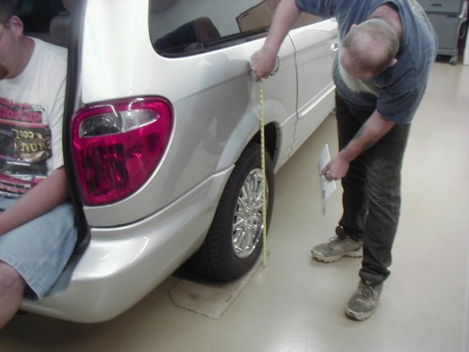
suspension-related concerns. Check all items that are specified.

Road Test

Visual inspection

Ride height measurement

Other (describe) ____________

_________________________

2. Based on the inspection, what is the needed action? ___________________________

__________________________________________________________________

__________________________________________________________________

__________________________________________________________________
