Name:_____________________________________
Date:_____________
Time on Task:_____________
Make/Model/Year:____________________________________
VIN:_________________________________
Evaluation (Enter number from 4, 3, 2, 1) :_________
Meets ASE Task: : (A4-A-1) P-1 Research vehicle service information such as fluid type, vehicle service history, service precautions, technical service bulletins, and recalls including vehicles equipped with advanced driver assistance systems (ADAS).

Research Vehicle Service Information
Page 343
Consult the service information and determine the following.

1. Check service information and check the following for the vehicle being serviced.
- Power steering fluid type __________________________________
- Technical service bulletin (list all that apply). _______________________
____________________________________________________________
____________________________________________________________
____________________________________________________________
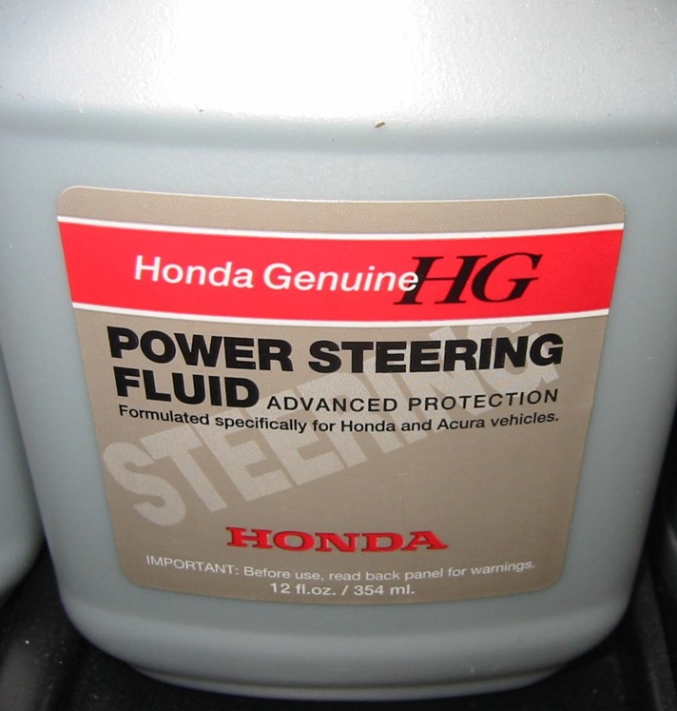

- Service precautions (list all that apply). ____________________________
____________________________________________________________
____________________________________________________________
____________________________________________________________

