Name:_____________________________________
Date:_____________
Time on Task:_____________
Make/Model/Year:____________________________________
VIN:_________________________________
Evaluation (Enter number from 4, 3, 2, 1) :_________
Meets ASE Task: : (A4-F-5) P-1 Repair tire following vehicle manufacturer approved procedure.

Tire Repair
Page 341
1. Locate the source of the leak by submerging the tire under water or by spraying the
tire with soapy water. Describe the location of the leak.

__________________________________________________

2. Remove the foreign object and use a reamer to clean the hole in the tire (tread area
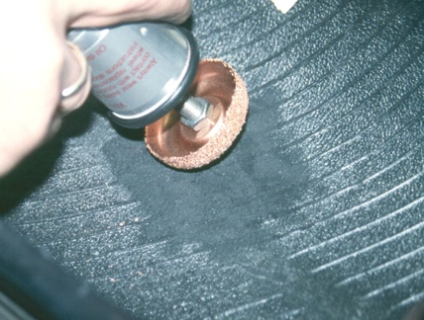
only).

3. Dismount the tire and buff the inside of the tire around
the hole.

4. Apply rubber cement to the buffed area.

5. Insert the repair plug from the inside of the tire.

6. Pull the plug through the puncture from the outside of the tire.

7. Use a stitching tool to make sure the inside of the patch is well adhered to the inside of
the tire.

8. Remove the tire and inflate to the air pressure specified by the vehicle manufacturer.

9. Check the repair for air leaks using soapy water.

OK NOT OK

