Name:_____________________________________
Date:_____________
Time on Task:_____________
Make/Model/Year:____________________________________
VIN:_________________________________
Evaluation (Enter number from 4, 3, 2, 1) :_________
Meets ASE Task: : (A4-F-6) P-1 Dismount, inspect, and remount tire on wheel (with/without TPMS); balance wheel and tire assembly.
Tire Replacement
Page 340
1. Check the instructions for the proper use of the tire changer. Describe the
recommended procedure.
__________________________________________________________________
__________________________________________________________________

2. Check all steps that were performed.
Removed the valve core (TPMS equipped tire/wheel assembly; check
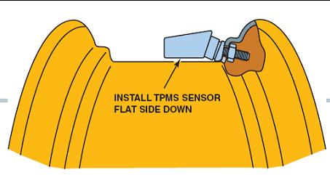
service information for the exact procedure to follow.)

Demount the tire from the wheel. Instructor OK __________________
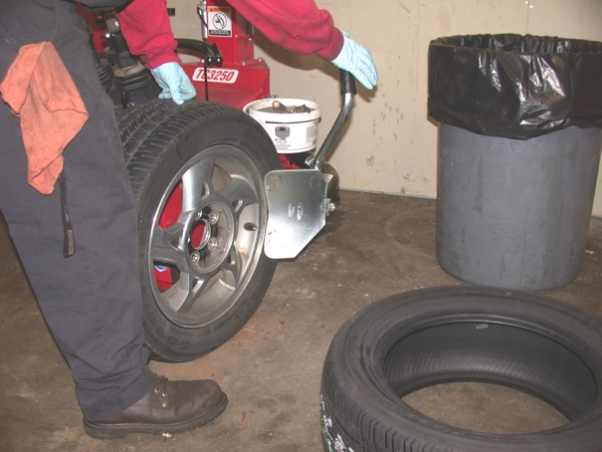
Clean bead seat.
Lubricate the tire bead.
Mount the tire and inflate to
specified inflation pressure.
3. Balance tire/wheel assembly.
Instructor OK __________________

