Evaluation (Enter number from 4, 3, 2, 1) :_________
Meets ASE Task: (A8-A-7) P-2 Diagnose the cause of excessive oil consumption, coolant consumption, unusual exhaust color, odor, and sound; determine needed action.
Engine Oil Dipstick Test

Name:_____________________________________
Date:_____________
Time on Task:_____________
Make/Model/Year:____________________________________
VIN:_________________________________
Page 34
1. Check the engine oil level and condition.

Level: ____low ____okay ____overfilled

Color: ____black ____dark brown ____amber
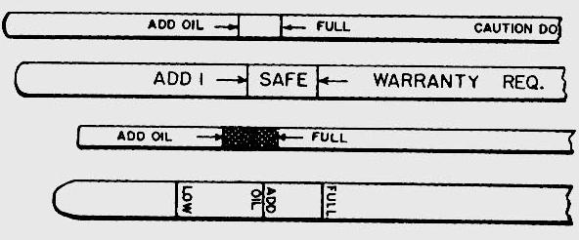
2. Ignite the oil on the dipstick:

_____ does not burn

_____ does burn

NOTE: If the oil on the dipstick burns, there is gasoline in the oil. This will
cause the engine to run rich by drawing the fuel through the PCV system.
Gasoline in the oil can also damage the engine due to the diluted oil not properly
lubricating the engine.

3. Drip oil onto the hot exhaust manifold:

does not bubble

does bubble

NOTE: If the oil bubbles on the exhaust manifold, coolant (water) is in the oil.

4. Rub the oil from the dipstick between your fingers:

does not feel gritty

does feel gritty

5. Based on the test results, what is the needed action? _________________________

