Name:_____________________________________
Date:_____________
Time on Task:_____________
Make/Model/Year:____________________________________
VIN:_________________________________
Evaluation (Enter number from 4, 3, 2, 1) :_________
Meets ASE Task: : (A4-F-10) P-2 Measure wheel, tire, axle flange, and hub runout; determine needed action.
Tire, Wheel, Axle, and Hub Runout
Page 339
1. Check service information for the specifications for radial and lateral runout.
Specification for radial runout = _________ (usually less than 0.060 inch).
Specification for lateral runout = _________ (usually less than 0.045 inch).
2. Using a runout gauge, rotate the tire and record the radial runout (roundness of the
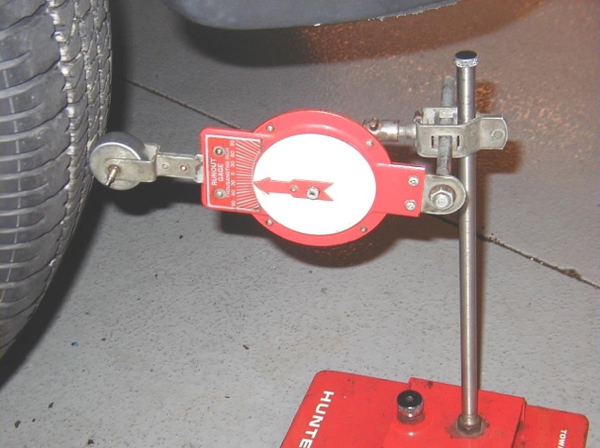
tires) and the lateral runout (side-to-side movement) of the tires.
Tire Radial Runout Lateral Runout
R.F. ______ _______
R.R. ______ _______
L.F. ______ _______
L.R. ______ _______
3. Using a dial indicator, measure the axle and hub runout.
Hub runout = ________ OK NOT OK
Flange runout = ________ OK NOT OK
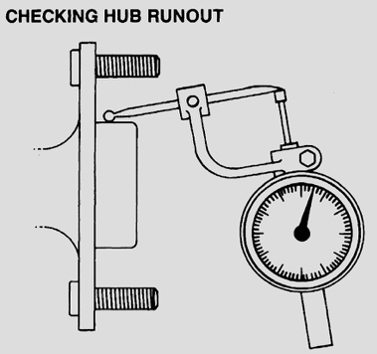
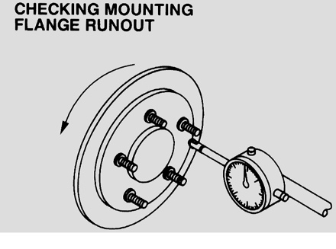

4. Based on the measurements, what needed action is needed?
______________________________________________________________
______________________________________________________________

