Name:_____________________________________
Date:_____________
Time on Task:_____________
Make/Model/Year:____________________________________
VIN:_________________________________
Evaluation (Enter number from 4, 3, 2, 1) :_________
Meets ASE Task: : (A4-F-2) P-1 Rotate tires according to manufacturer’s recommendations including vehicles equipped with tire pressure monitoring systems (TPMS).

Tire Rotation
Page 338
1. Check the service information for the recommended tire rotation method.
Cannot rotate tires on this vehicle
Modified X method
X method
Front to rear and rear to front
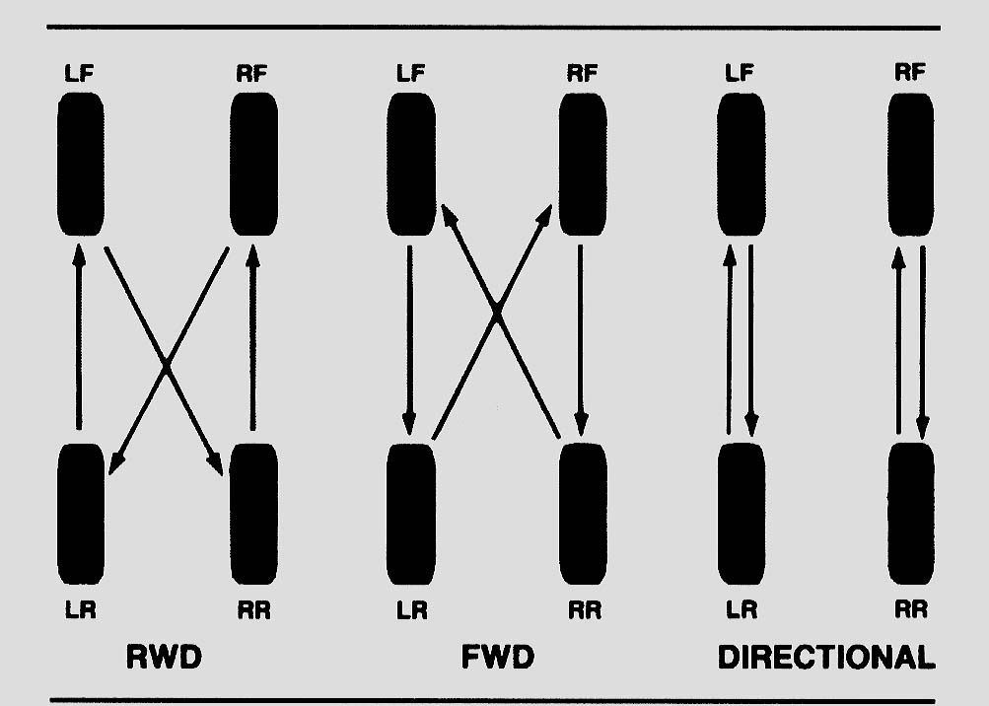

2. Hoist the vehicle safely to a good working position (chest level).

3. Remove the wheels and rotate them (if possible) according to the vehicle
manufacturer’s recommendation.

4. Check and correct the tire air pressures according to the service information on the
placard on the driver’s door.
Specified front tire air pressure = ________

Specified rear tire air pressure = ________

5. Tighten the lug nuts to factory specifications. What is the factory specification?
________________________

6. Lower the vehicle and move the hoist pads before driving the vehicle out of the
service stall.

