Name:_____________________________________
Date:_____________
Time on Task:_____________
Make/Model/Year:____________________________________
VIN:_________________________________
Evaluation (Enter number from 4, 3, 2, 1) :_________
Meets ASE Task: : (A4-F-9) P-1 Diagnose wheel/tire vibration, shimmy, and noise; determine needed action. (A4-F-11) P-1 Diagnose tire pull problems; determine needed action.

Tire Vibration and Pull Diagnosis
Page 337
1. Check service information for the specified procedures to follow when diagnosing
vibration and pull concerns. Describe the recommended procedures.

________________________________________________________________

________________________________________________________________

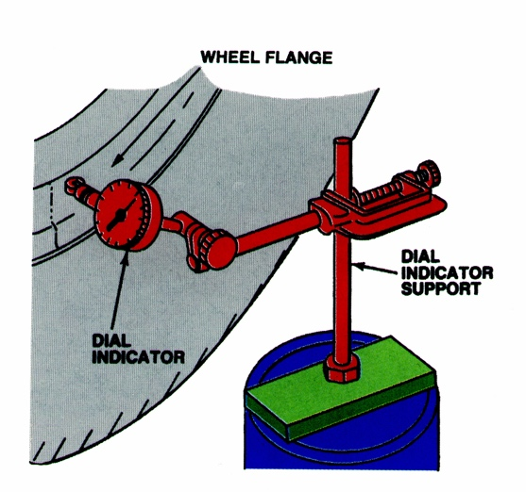
2. Check all that are specified:

Test drive

Use an electronic vibration analyzer (EVA)

Visual inspection

Measure radial runout ______________

Measure lateral runout ______________

Rotate tires

Other (describe) _______________________________________________

____________________________________________________________

3. Based on the diagnostic procedures, what is the needed action?

__________________________________________________________________

__________________________________________________________________

