Name:_____________________________________
Date:_____________
Time on Task:_____________
Make/Model/Year:____________________________________
VIN:_________________________________
Evaluation (Enter number from 4, 3, 2, 1) :_________
Meets ASE Task: : (A4-F-6) P-1 Identify indirect and direct tire pressure monitoring systems (TPMS); calibrate/relearn system; verify operation of instrument panel lamps. (A4-F-7) P-1 Demonstrate knowledge of steps required to remove and replace sensors (per OEM/sensor manufacturer) in a tire pressure monitoring system (TPMS).
Tire Pressure Monitoring System
Page 335
1. Check service information to determine the specified procedure to follow when
inspecting, diagnosing, or calibrating the tire pressure monitoring system. Describe
the specified procedures.

_________________________________________________________________

_________________________________________________________________

_________________________________________________________________

2. With what type of TPMS is the vehicle equipped?
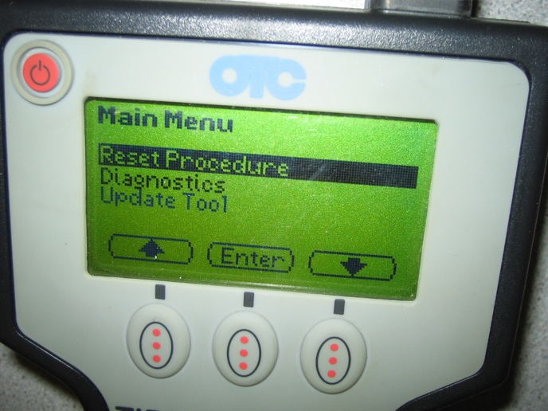
Indirect

Direct

If direct-type system, what type of
sensor is used?

Stem-mounted

Banded

Unknown

3. Is recalibrating the sensors needed if the tires are rotated?

Yes (If yes, what is the procedure?) ________________________________

____________________________________________________________

No

