Meets ASE Task: (A5-G-1) P-1 Identify and inspect electronic brake control system components (ABS, TCS, ESC); determine needed action.

Name:_____________________________________
Date:_____________
Time on Task:_____________
Make/Model/Year:____________________________________
VIN:_________________________________
Evaluation (Enter number from 4, 3, 2, 1) :_________
Traction Control/Vehicle Stability

Page 333
1. Check service information for the specified procedure to follow when inspecting the
electronic brake control system. Describe the procedure. ______________________
_________________________________________________________________
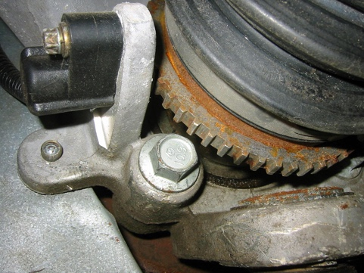
_________________________________________________________________
2. Describe the location of the following components.
- Wheel speed sensor ________________
________________________________
________________________________
________________________________
________________________________
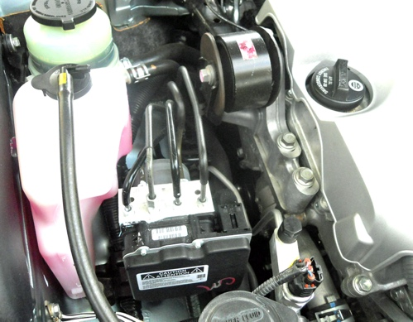
- Hydraulic control assembly __________
_________________________________
_________________________________
_________________________________
_________________________________

- Other (describe) ____________________________________________________________
____________________________________________________________
____________________________________________________________

_____ 3. Based on the inspection, what is the needed action? ___________________________
__________________________________________________________________

