Meets ASE Task: (A5-G-1) P-1 Identify and inspect electronic brake control system components (ABS, TCS, ESC); determine needed action.
Name:_____________________________________
Date:_____________
Time on Task:_____________
Make/Model/Year:____________________________________
VIN:_________________________________
Evaluation (Enter number from 4, 3, 2, 1) :_________
Electronic Brake (ABS) Component Inspection
Page 326
1. Check service information for the identification of the electronic brake system and the
exact procedure to follow during an inspection.
Type of electronic brake system = ______________________________________
Describe the specified inspection procedure: _____________________________
__________________________________________________________________

2. Inspect all components of the electronic brake system. (check all that apply)
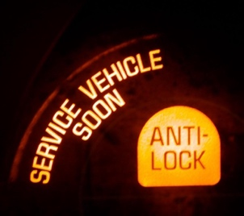
Master cylinder OK NOT OK
Electrohydraulic unit OK NOT OK
Accumulator(s) OK NOT OK
Electronic control unit OK NOT OK
Wheel speed sensors OK NOT OK
Other (describe) ___________________________________

3. What tools or equipment was needed to perform the inspection and/or testing? (check
all that apply)

Scan tool DMM Mirror

Pressure gauge Other (describe) ____________________________

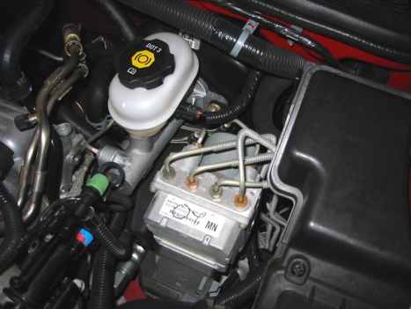
4. Based on the inspection, what is the needed action?
_________________________________________

_________________________________________

