Meets ASE Task: (Task not specified by ASE)
Name:_____________________________________
Date:_____________
Time on Task:_____________
Make/Model/Year:____________________________________
VIN:_________________________________
Evaluation (Enter number from 4, 3, 2, 1) :_________
Master Cylinder Pushrod Length
Page 325
1. Check service information for the specified procedures and specifications for checking
and adjusting master cylinder pushrod length.

__________________________________________________________________
__________________________________________________________________
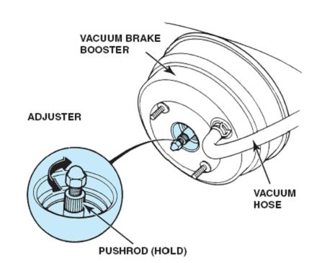

2. Where is the measurement taken?
__________________________________________________________________

3. Is a “go-no go” gauge needed? If so, what is the part number? ___________________

4. Describe the symptoms if the master cylinder pushrod length is not correct.
__________________________________________________________________
__________________________________________________________________

