Meets ASE Task: (A5-E-4) P-2 Inspect and test hydraulically assisted power brake system for leaks and proper operation; determine needed action.
Name:_____________________________________
Date:_____________
Time on Task:_____________
Make/Model/Year:____________________________________
VIN:_________________________________
Evaluation (Enter number from 4, 3, 2, 1) :_________
Hydro-Boost Test
Page 324
1. Check the service information for the specified Hydro-Boost testing procedure for the
vehicle being serviced.
_________________________________________________________________

2. Start the testing of a Hydro-boost power brake assist system by carefully inspecting
the following components:
Power steering fluid level OK NOT OK
Power steering pressure hoses for leaks OK NOT OK
Power steering pump drive belt OK NOT OK
Master cylinder brake fluid level OK NOT OK
Visually inspect the Hydro-boost assembly
for evidence of power steering fluid leaks OK NOT OK

3. Check the operation of the base hydraulic brakes by depressing the brake pedal several
times with the engine "off" until the brake pedal feels firm. Continue to apply force to
the brake pedal. The brake pedal should not drop.
OK NOT OK master cylinder or hydraulic system fault is
indicated)

4. With your foot still applying force to the brake pedal, start the engine. If the
Hydro-boost system is functioning correctly, the brake pedal should drop.
OK NOT OK
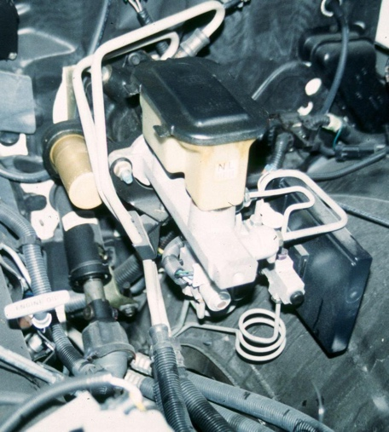
5. To check the power steering pump for proper operation,
connect a power steering pressure gauge or pressure and
volume gauge between the pump and the Hydro-boost
unit. Start the engine and observe the pressure and
volume gauges.
Pressure at idle = _________
(should be less than 150 psi)
OK NOT OK

Volume at idle = __________
(should be at least 2 gallons per minute)
OK NOT OK

