Meets ASE Task: (A5-E-3) P-2 Inspect vacuum-type power booster unit for leaks; inspect the check-valve for proper operation; check vacuum supply (manifold or auxiliary pump) to vacuum-type power booster; determine needed action.
Name:_____________________________________
Date:_____________
Time on Task:_____________
Make/Model/Year:____________________________________
VIN:_________________________________
Evaluation (Enter number from 4, 3, 2, 1) :_________
Vacuum-Type Power Booster
Page 323
1. Check service information for the recommended procedures to follow to determine if
a vacuum-type power brake booster has a vacuum leak.
_________________________________________________________________
_________________________________________________________________
_________________________________________________________________

2. Most vacuum-type power boosters should be capable of supplying 3 or more assisted
stops with the engine off. How many were found? __________

3. Most vehicle manufacturers specify checking for leaks both around the outside (under
the hood), as well as in the valve area under the instrument panel.
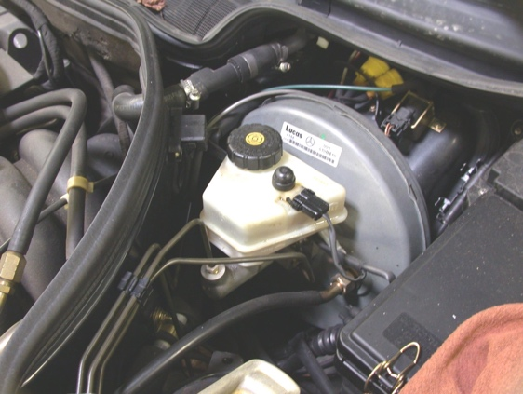
Under hood:

OK NOT OK

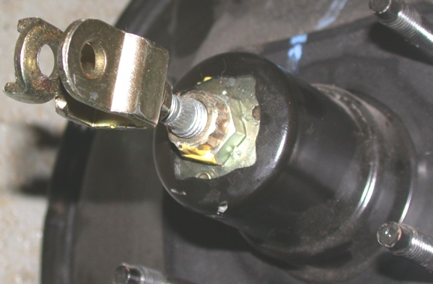

Valve area:

OK NOT OK

4. Based on the test results, what is the needed action? __________________________

__________________________________________________________________

