Meets ASE Task: (A5-E-3) P-2 Inspect vacuum-type power booster unit for leaks; inspect the check-valve for proper operation; check vacuum supply (manifold or auxiliary pump) to vacuum-type power booster; determine needed action.
Name:_____________________________________
Date:_____________
Time on Task:_____________
Make/Model/Year:____________________________________
VIN:_________________________________
Evaluation (Enter number from 4, 3, 2, 1) :_________
Vacuum Supply/Manifold or Auxiliary Pump
Page 322
1. Check service information for the recommended procedures and specifications for
checking vacuum supply to power booster.
_________________________________________________________________

_________________________________________________________________

_________________________________________________________________

2. Is the vehicle equipped with an auxiliary vacuum pump? Yes No

3. Most vehicle manufacturers specify that a vacuum “T” be installed in the vacuum line
between the intake manifold and/or auxiliary pump and the vacuum power brake
booster assembly. Most manufacturers specify a minimum of 15 in. Hg. of vacuum be
measured.
Actual vacuum measured at the power brake booster = __________

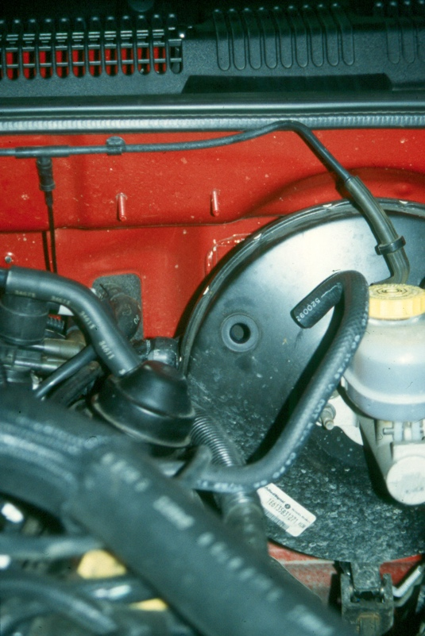
OK NOT OK

